# 1CHAPTER ONE

**Proposal**

**1.1 Introduction**

**Changes in Information System allow educational institutions to utilize databases and applications such as online registration, online uploading and downloading reading materials and posting updated information thus making the accessing of records centralized. One of the changes that came about is the web-based applications. These applications improve the traditional manual processing systems. Thus, most universities switch to the web-based system because of its affectivity to acquire process, store and retrieve information via the Internet. Moreover, this proposed system is aimed to perform online uploading modules, downloading modules and assignmentsand also post up to dated information for distance learners.**

**1.2 Motivation**

**We are very interested to develop web based system for Debre Berhan University Continuing and Distance Education because of the following reasons:-**

* **Until this day computerized system wasn’t developed**
* **To solve complexity of the office by develop web-based system**
* **To improve our knowledge regards to how to develop systems related to teaching and learning process**
* **To provide alternative solutions with some prototype to Continuing and distance education**

## 1.3 Background

**Debre Berhan University Continuing and Distance Education program was established in 1999 and the system is paper based, no one has been tried to automate it. Still the office is working different activities through this manual system. Because of this, the office is facing a lot of problems such as loss of data or paper; wastage of time in data processing, lack of manageable tasks, burden of work on workers, checking process payment takes long time etc.**

**As the CDE becomes growing its service providing also becomes complex and it is difficult to accomplish in efficient way because the system is manual system. So, needs to be automated.**

**1.4 Problem Statements and justifications**

**Debre Berhan University continuing and distance education office currently have so many problems; because, the system is manually operated. In each and every semester students are being registered by paying fee after registering, students get ID card and learning materials (modules) that attached with different assignments, before the examination date and they take tutorial and at the time of examination they come back with their assignment paper and take the exam.**

**Employees also facing a lot of problems with the existing system**

1. **The basic problem of continuing and distance education is lack of student’s satisfaction**
2. **Overburden work for the departments and CDE office during providing the service to the students like distributing materials for students is another problem.**
3. **Students don’t have the opportunity to get updated information on time**
4. **The students must come in each semester, starting from first year up to graduating tobe registered, to take tutorial and reading materials andthis takes time and cost.**

## 1.5 Objective of the project

### 1.5.1 General objectives

**The general objective of this project is to develop interactive web-based system in order to overcome the problems some subsystems with the existing system.**

### ****1.5.2 Specific objectives****

* **To minimize work complexity of the existing system**
* **To minimize cost of copying or duplicating materials**
* **To reduce wastage of time to submit assignments**
* **To enable new applicants online applying**

**1.6 Significance of the project**

**After completion of this project it will provide the following significant forthe office of CDE; it will reduce cost of learning materials to duplicate and distribute.**

**It provides updated information to distance learners such as announcing the registration date, new curriculum and etc.**

* **Students can get updated information from internet**
* **The students can download learning materials (module) and assignments**

## 

## 1.7 Scope of the project

In Debre Berhan University Continuing and Distance education office the following sub systems are required to be automated.

* Providing tutorial online
* Online examination
* Online video learning
* Online registration and payment
* Distributing module via the internet
* Distributing assignments for distance learners

**Because of taking the time and budget allotted to this project in to account only selected activities are going to be automated and implemented in this proposed system. Specifically the activities that are supposed to be automated are:**

* **Online application**
* **Distributing modules through internet**
* **Submission of assignment via the internet**
* **Distributing assignments for distance learners**

## 1.8 Methodology

**The methodology we adopted in this project is usingdifferent types of tools which are used to develop web based application such asHtml, PHP, MySQL, and xampp server etc.**

### 1.8.1 Data collection method

**The methods we use for data collection are:**

* **Interviewing: to find which problems are available in the current system, important questions will be raised while interviewing.**
* **Document analysis: reading the document available in the office.**

**1.8.2Development tools and languages used**

**We used UML,Edraw and Microsoft Visio while we are designing our new system.The development tools that we will use are:**

* **For the front-end application we used PHP.**
* **For the back-end application we used MySQL database.**
* **And we use Xamp server to configure a MySQL database and to use phpapplications for easy configuration and maintenance.**
* **Server side scripting: PHP**
* **Client side scripting: by considering the following characteristics we use java script. It can be embedded in HTML page and it is very popular in validation process.**
* **Power point and MS-word: for presentation.**
* **Static webpage: HTML is highly flexible with CSS to use different layouts**

### 1.9 Limitations

**Due to the shortage of time and other mini projects the following activities will not include to be automated in the existing system. It is better to inform others who are interested to do on this project.**

* **Providing tutorial online**
* Online examination
* **Online video learning**
* **Online payment**

### 1.10 Risk Assessment & Management

**The project can’t be completed as it is initially planned. This is due to the fact that a problem may happenin the process of project development. We assumed the following risks can be encountered:**

* **The unavailability of data source (information gathering) on time may extend the project completion time. We will manage this problem by searching information from website of Debre Berhan University**
* **Damaging the computers that we work on, it will be managed by using backup.**
* **Unavailability of internet also another problem we will use other reference materials**
* **Shortage of Time. We managed such problem by using additional time from our rest time.**
* **Virus can attack our project. We used updated antivirus to manage this problem. Power fluctuation problem. It is using laptop that have high power pack ups are used.**

**1.11 Time Schedule**



**Table 2 Time table of the project group**

**1.12 Budget**

|  |  |  |  |  |
| --- | --- | --- | --- | --- |
| No | Requirement | Amount | Price | total |
| 1 | Paper | 2dozen | 100 | 200.00 |
| 2 | Pen | 10 | 3 | 30.00 |
| 3 | Pencil | 2 | 1.5 | 3.00 |
| 4 | CD-R | 5 | 6 | 30.00 |
| 5 | CD-RW | 1 | 30 | 30.00 |
| 6 | mislanous |  |  | 100.00 |
| 7 | Mobile card |  |  | 100.00 |
| 8 | Ruler | 1 | 5 | 5.00 |
| 9 | Printing paper |  |  | 250.00 |
| Total 748 Birr | | | | |

**1.13 Feasibility analysis**

**Feasibility is a measure of how beneficial and practical the development of an information system will be. Given enough time, money, and personnel, almost all system projects are feasible. Feasibility studies provide the information that allows management to:**

* **Pick one of several possible alternative systems that meet the requirements.**
* **Decide if a system project should proceed to the next phase.**
* **Choose between several systems projects that must compete for the same set of limited resources.**

**1.13.1 Economic feasibility**

Economic feasibility is a measure of how cost effective the proposed solution will be. It is possible to develop the proposed system in minimum cost and also can be hosted in lower price. The distance education can be used after completion free of cost.

**1.13.2 Operational feasibility**

**Operational feasibility is a measure of how well the solution will work in the organization. Operational feasibility is dependent up on the human resources available for the system. This system web based system for distance education in Debre Berhan University will attain its desired objectives. It can solve the problems in distributing module and assignment; therefore it will minimize the amount of effort to do all through manually. And it will perform the basic content management functionality.**

**1.13.3 Technical Feasibility**

**Technological feasibility measures the practicality of a specific technical solution to the problem. It is also a measure of the availability of technical resources and expertise. Technical feasibility is assessing the organization‘s ability to construct the system. Since This online system for educational purpose need technical resources to implement, like computer with network. We expect that, the system can be operated in simple way and all users can access easily by giving some training for them.**

**1.14 Team organization**

**The project team member is structured with 5 members, one group leader, one deputy leader, one secretary, and 2 other members’Problem solving takes place in group. Decision making on problem solving process are made by group member’s agreement, which is much better than individual decision making.**

# CHAPTER TWO

**Description of the existing system**

**2.1 INTRODUCTION**

**The existing system of Debre Berhan University Continuing and Distance Education is manually operated. Different activities are performed as follow:**

**Distributing modules, allocating assignments, announcing registration dates and some other activities are performed by CDE office**

**The current system we have observed is faced a lot of problems, due to this reason we analysis those problems to provide some alternative solutions.**

## 2.2Problem of the existing system

**As we have observed in the data collecting phase, the main problems in DBUCDEare lack of student satisfaction because they waste much of their time to take tutorial and submit assignments because they come from distance.**

**The students must go to their center to collect modules, submit assignments. This makes the students unsatisfied.**

**Overburden of work on the employees is also another problem of the current system in CDE during duplicating and distributing modules. Each course has its own module to be distributed per student, due to this reason the department makes copy of module that facing work overloading it.**

**Students don’t get the opportunity to get up to dated information on time. Because, students get the information about exam date, tutorial date, assignment submission dates from their department. In case if there is any change occur in the schedule it’s impossible to address updated information to all students. The office uses different mechanism such as transmitting the information using media this is costly. Generally those problems can be defined as:**

* **Lack of security because there is no centralized database**
* **Time consuming because of it is manually operated**
* **Lack of consistency of data**
* **Data redundancy**
* **Loss of data because, it is a manually system**

### 2.3 Role players in the existing system

**Student**

* **Applying to be registered**
* **Collecting modules or reading materials from centers**
* **Collecting assignments from the centers**
* **Take tutorial by coming to the university**
* **Submit assignments**
* **View grade from registrar office**
* **Receive degree certificate from registrar**

**Office of CDE**

* **Assign instructors together with course coordinator**
* **Preparing reading materials or modules**
* **Distribute modules**
* **Post updated information**
* **Announcing registration date**
* **Receive registered students from registrar office**
* **Duplicating modules**
* **Assign instructors for a particular course**
* **Controlling the overall teaching and learning process in allfields of studies.**

## ****Finance department****

* **Process the payment**
* **Checking the payment**
* **Give receipts for those applicants**

## ****Office of registrar****

* **Checking the receipts weather the applicant committed the expected payment.**
* **Checking the applicants profile and perform registration.**
* **Prepares report about registered students and submit to CDE office.**
* **Registering student.**
* **Preparing and giving student’s grade report.**
* **Process withdrawal and give withdrawal form.**
* **Preparing and giving degree certificate for students.**

## 2.4 The existing system process

### 2.4.1 Criteria for admission

**An applicant who wants to join Debre BerhanUniversityContinuing and Distance Education program findsoffice information about the available programs and the admission requirement through telephone, post office, watching television or listening radio. The office coordinator informs the applicant about the available programs and the required criteria to join the distance education. Then the applicant should have to come on time to apply. The coordinator gives the application form for applicant and applicant fills the application form and submits with supporting documents such as entrance exam result and photo copies of diploma and required information. The office coordinator verifies application form and supporting documents. After verifying the documents the coordinator determines whether the applicant fulfills the criteria to admission requirements according to the following measurements.**

1. **Applicant who have Ethiopian school leaving certificate examination (ESLCE). It must be qualified ministry of education university entrance result of higher education institute. Applicant who have successfully completed 10+2 (preparatory) education and qualified by ministry of education(MOE) higher educational institute university entrance result .**
2. **Admission through diploma certificate applicant with specified GPA. If the applicant fulfills one of the above requirements he/she will get unique students ID. Then the new students will get register for course.**

### 2.4.2 Tutorial providing

**In Debre Berhan University distance education program, students can get tutor class or face to face education once in term every course given. Tutorial class are scheduled and organized by the department course coordinators and CDE office. In addition to that, the office selects tutors from departments and made agreement with instructors of the specified courses to be given. Finally according to the schedule the tutorial class will be carried out.**

**2.4.3 Registration process**

**A student can be registered in DBUCDE those fulfill the criteria which are described in the admission requirement and another additional criteria. These are:**

* **An applicant should have to pay for application**
* **An applicant should have to pay for registration**
* **The student should have to commit educational fee**
* **The student should have to pay for tutorial**

**The registration will be held based on the payment status. The payment will be performed by Debre Berhan University finance office.**

* **The students those who want to be registered should have to bring receipts that ensures the expected payment from finance department**
* **The receipt should be submitted to registrar office to be checked then the registrar can register the applicant based on the payment status**

**2.5 Work flow of the existing system**



**Work flow of the existing system**

**2.6Report generation in the existing system**

**The reporting process in the Continuing and Distance Education is described below:**

* **The CDE office gives specific and clear criteria about those applicants to join distance education to registrar office**
* **Then the registrar office set those criteria and informs to those applicants and registrar office sends the applicant for payment purpose to the finance department then**
* **After accomplishment of payment the finance department gives them receipts that ensures payment and applicant go to registrar to be registered**
* **Then the registrar office sends a full of the report about registered students to the distance education program office**
* **Based on this report the office can provide modules and other relevant materials for the students by identifying their ID Number**

**2.7 Business Rules**

This part specifies and gives understanding of activities which are being done in the existing system in terms of business rule.

* **The CDE office is the one who is responsible to control the overall teaching learning process.**
* **The office Determines registration date and clarify required criteria.**
* **Applicants who want to join Debre Berhan University must have full of documents and qualification of Ministry of education certificates.**
* **Student should be registered on the specified registration date.**
* **Each student should have unique identification card to be identified.**
* **Student should have to pay education fee to get access in this program.**
* **To join in Debre Berhan University distance education, to register for one field of study there must be greater than 40 applicants for a single department.**
* **Choice of field study is based on the applicant’s interest.**

**2.8 Practice to be preserved**

**In the CDE office there are some activities to be preserved even if the system will be automated, for example: printed document will never disappear because, every time in the office it is required, auditing also performed by looking for paper based data.**

**Secondly, structure of the existing system may not be changed because it is structured based on their need and in the aspiration of the university.**

**2.9 Alternative solutions for the existing system**

### The current system is facing a lot of problems as we described in the problems of the existing system. The following can be alternative solutions for the CDE office.

**The possible solution may be the following:**

* **Developing web-based system**
* **Opening additional branches or centers in many areas**
* **Changing the structure of the organization**

**From the above alternative solutions we selected developing web based system.**

### 2.10 The proposed system

**The proposed system that we analyzesome alternatives that can solve some portion of the existing system. When we see the solution, making the organization automated and transaction system, it will solve most of the problems in the functioning of the office. This project has much significance, since it is designed to solve particular problem, providing the solution is the main significance but to specify the following are also the significances.**

* **Reduce the time and task required to perform the operation within the office**
* **It will change the manual processing to computerize some portion of the system.**
* **It will provide speed, efficient, Flexibility, reliability, and security not the whole system.**
* **For students, better satisfaction of the speed provided by the office in module distributing and submitting assignment.**
* **And it improved the moral (motivation) of the users.**

**2.10.1 Functional Requirements**

* **Login into the system; authorized user can login the system**
* **Manage user’s account including creating and updating**
* **Uploading modules and assignments; enable an administrator upload module and assignment questions as well as download assignment answers submitted by students.**
* **Downloading modules and assignments; enable student to download module and download assignment questions.**
* **Post updated information; for students such information is, registration date, changed policies in the distance education etc.**
* **Online application to be registered**

**2.10.2Non-Functional Requirements**

**Non-functional requirements are requirements that specify criteria that can be used to judge the operation of a system rather than specific behaviors. Those are:**

* **Security: the system must confidentially be controlled from being accessed byunauthorized users.**
* **Availability: the system should be available at any time, if by any means the system fails, the system should store a backup database.**
* **Performance: the system should be responsibly fast in order to access the required information and modules and assignment easily.**

**Easy searching and retrieving of information is required, they need to have a centralized database to store and access information easily and generation of timely report is required.**

**2.11 Activities of the proposed system**

**2.11.1 Application process**

**To join Debre Berhan University Continuing and Distance education program the registration process isperformed by registrar office. The registration process is performed as every students or applicant who want to join DBU continuing and distance education and fulfills the entire requirement can get registration after approved all supportive documents and photos. After the registrar officers complete the registration process, registrar office can login to the system and submits the report about those registered students.**

**2.11.2Upload modules and assignments**

**Students those who have been registered for the course can download all modules from internet that is posted by the CDE office. They can read online or download the modules. Assignment questions are uploaded for those who registered students in each course of a given course.**

**2.11.3 Submission of assignments**

**Every student is expected to submit his/her assignments via internet; the student should have to write his/her full name, ID number, course name, department name ,academic year, semester in the form. The system verifies the information provided by the student and then submits by clicking the submit button.**

**CHAPTER Three**

**Analysis deliverable of the new system**

**3.1 Introduction**

In chapter two, we have discussed the different activities of existing system and the main processesinvolved in managing the continuing and distance office activities. In this chapter thefunctional requirements of the proposed system will be modeled using UML models with different types of diagrams.

**3.2 Use case model**

**To model a system the most important aspect is to capture the dynamic behavior. To clarify in details, dynamic behavior means the behavior of the system when it is running or operating. So only static behavior is not sufficient to model a system rather dynamic behavior is more important than static behavior. In UML there are five diagrams available to model dynamic nature and use case diagram is one of them. Now as we have to discuss that the use case diagram is dynamic in nature there should be some internal or external factors for making the interaction.**

**These internal and external agents are known as actors. So use-case diagrams are consists of actors, use cases and their relationships. The diagram is used to model the system or subsystem of an application. A single use case diagram captures a particular functionality of a system.So to model the system we used the following use case diagrams.**

**3.2.1 Actor identification**

**The purpose of actor analysis is to identify all of the actors that interact with the system. An actor has a role in that interacting with the system.**

**The actors that interact with the system are:-**

* **Administrator**
* **Student**
* **Registrar officer**
* **Office Director**

**3.2.2 Use-case identification**

**Identifying the activities that are mainly performed on the proposed system is the basic thing in analyzing a new system. The following use cases have been identified from the system specification.**

* **Upload module**
* **Download module**
* **Upload assignment**
* **Download assignment**
* **Postupdatedinformation**
* **Manage user account**
* **Login**
* **Generate report**
* **Register student**

**Use case diagrams graphically describe system behavior (use cases). These diagrams present a high level view of how the system is used as viewed from an outsider’s (actor’s) perspective. From the identified use cases and actors the use case diagram of the system is shown in Fig3.1**



|  |  |
| --- | --- |
| **Use-case name** | **Upload module** |
| **Identifier** | **Uc1** |
| **Description** | **The process will start by activated the system or the window and then home page displays the login link also displays.** |
| **Actor** | **Administrator** |
| **Pre-condition** | 1. **An administrator should have to enter a valid user name and password.** 2. **The system should verify the input user name and password.** |
| **Post-condition** | 1. **If an administrator entered valid user name and password then he/she go to user’s page and upload module successfully.** |
| **Basic course of actions** | **Step 1: Administrator should have to enter his/her username and password**  **Step 2: The system verifies whether the user is authorized and generates accepting or rejection message.**  **Step 3:Theadministrator should clicks on upload module link. Then browses where the file to be uploaded**  **Step 4: Then administrator should select the file and click on upload button.** |
| **Alternative course of action** | **Step 3:If the size or type of file to be uploaded is out of size, the administrator can’t upload the file.**  **Step 2: If there is another problem is occurred** |

**Use-case scenario for upload module**

**Use-case scenario for download module**

|  |  |
| --- | --- |
| **Use-case name** | **download module** |
| **Identifier** | **Uc2** |
| **Description** | **The process will start the student by activated the system or the window and the home page and login link will be displayed.** |
| **Actor** | **Student** |
| **Pre-condition** | 1. **Student must insert his/her ID number as user name and password.** 2. **To get download a module student should have to pay first.** 3. **The system should to verify whether it is valid or not.** |
| **Post-condition** | 1. **If his/her ID number is correct, then the student enables to download a module.** |
| **Basic course of actions** | **Step 1: The student should have to insert Id number as his/her user name and password.**  **Step 2: The system authenticates its validity.**  **Step 3: The system should have to check the payment status of the student.**  **Step 4: The student should have to choose the content to download and fill his/her department name and module name.** |
| **Alternative action** | **Step 1: if user name inserts wrong Id number you are not user try again message.**  **Step 2: if a students didn’t pay the fee you can’t download message displays.**  **Step 3: If the user enters wrong department name can’t download or access message will be displayed.** |

|  |  |  |  |  |  |  |  |
| --- | --- | --- | --- | --- | --- | --- | --- |
| **Description** | |  |  | | --- | --- | | **Post-condition** | 1. **If an administrator entered valid user name and password then he/she upload the assignment questions.** 2. **And also student uploads his /her own assignment’s answers according student Id. Finally logout the system.** | | **Basic course of actions** | **Step 1: user validation**  **Step 2: The student can upload assignment answers after he/she completed the assignment by specifying course code, department name and Id number.**  **Step 3: The system should have to check the submission date.** | | **Alternative course of action** | **Step 3: If the student didn’t fill correct information error message will be displayed.** |  1. **UseThis process can be performed by administrator as well as by student. An administrator uploads assignment questions for distance learners to be answered.** 2. **Student downloads the assignment questions and after completion the student should submit the answers to be corrected to the distance education office through the website** |
| **Actors** | **Student and Administrator** |
| **Pre-condition** | **Step 1: An administrator should have to enter a valid user name and password to upload assignments.**  **Step 1: The system should validate the user by checking user name and password or Id number.** |

**-case 3: upload assignment**

**Use-case scenario for download assignment**

|  |  |
| --- | --- |
| **Use-case name** | **Download assignment** |
| **Identifier** | **Uc4** |
| **Description** | **This process can be performed by administrator as well as by student.**   1. **An administrator can download assignment answers submitted by distance learners.** 2. **Student can download assignment questions that uploaded by administrator.** |
| **Actor 1** | **Administrator** |
| **Actor2** | **Student** |
| **Pre-condition** | 1. **An administrator should have to enter a valid user name and password to download the assignment answers that submitted by the student.** 2. **Student can download assignment questions to do so.** |
| **Post-condition** | 1. **If an administrator entered valid user name and password then he /she can download the assignment.** 2. **Student can download successfully and the system checks all information Student Id, name department otherwise can’t download assignment.** |
| **Basic course of actions** | 1. **Administrator should have to enter his/her username and password** 2. **The system generates the user’s user name and password and generates accepting or rejection message.** 3. **Then student clicks on download assignment link.** 4. **Then selects the content which the user wants to download.** |
| **Alternative course of action** | 1. **Error message will be displayed.** |

**Use-case scenario for post updated information**

|  |  |
| --- | --- |
| **Use-case name** | **Post updated information** |
| **Identifier** | **Uc5** |
| **Description** | 1. **The administrator posts updated information such as registration date and some changed policies in the distance education office.** |
| **Actor** | **Administrator** |
| **Pre-condition** | 1. **An administrator should have to enter a valid user name and password in order to post information.** |
| **Post-condition** | 1. **If an administrator entered valid user name and password then he/she can post information for those users including the student. Finally logout the system.** |
| **Basic course of actions** | **Step 1: Administrator should have to enter his/her username and password.**  **Step 2: Then the system verifies the validity. If user name and password are correct the posting information page will be displayed.** |
| **Alternative course of action** | **Step 1: If Administrator inserts wrong user name and password can’t post information.** |

|  |  |
| --- | --- |
| **Use case name** | **Manage user account** |
| **Identifier** | **Uc6** |
| **Description** | 1. **An administrator manages users’ account.** 2. **Updates user account like changing user name and password.** 3. **Administrator can delete user account such as student’s account for example, during termination or leaving the distance education program.** 4. **Administrator creates new account for users.** |
| **Actor** | **Administrator** |
| **Pre-condition** | 1. **An administrator should have to enter a valid user name and password in order to create, update and delete user account.** |
| **Post-condition** | **If an administrator entered valid user name and password then he/she can update, create and delete user account successfully. Finally logout the system.** |
| **Basic course of actions** | 1. **Administrator should have to enter his/her username and password.** 2. **Then the system should verify the user name and password.** 3. **The administrator should have to search the user’s account to be modified.** 4. **User’s account will be displayed.** |
| **Alternative course of action** | 1. **Confirmation message will be displayed.** |

**Use-case scenario for manage user account**

**3.3 Conceptual Class diagram**

**The class diagram is a static diagram. It represents the static view of an application. It describes the attributes and operations of a class and also the constraints imposed on the system. The class diagrams are widely used in the modeling of object oriented systems because they are the only UML diagrams which can be mapped directly with object oriented languages.**

**The class diagram shows a collection of classes, interfaces, associations, collaborations and constraints. It is also known as a structural diagram. They are used to describe the structure of the system in terms of classes. Class diagrams describe the system in terms of objects, classes, attributes, operations, and their association. Identified classes and relationship among them is shown in Fig 3.2.**



**Fig 3.3.1 conceptual class diagram**

**3.4 Activity diagrams**

**Activity diagram is another important diagram in UML to describe dynamic aspects of the system. Activity diagram is basically a flow chart to represent the flow form one activity to another activity. The activity can be described as an operation of the system. So the control flow is drawn from one operation to another. This flow can be sequential, branched or concurrent. Activity diagrams deals with all type of flow control by using different elements like fork, join etc.**

**The following activity diagrams are specified in the new system of continuing and distance education office.**



**Figure 3.4.1 activity diagrams for user login**



Fig 3.4.2Activity diagrams for download module



Figure 3.4.3Activity diagram for upload module



Fig 3.4.4 activity diagram for upload assignment



Figure 3.4.5 activity diagram for post information



Figure 3.4.6 activity diagram for generate report



**Figure 3.4.7Activity diagram for manage user account**



Figure 3.4.8Activity diagram for student registration

**3.5 Sequence diagram model**

**A sequence diagram links use case with objects. It shows the interaction between participating objects in a given use case. It is helpful to identify the missing objects that are not identified in the analysis object model. From the use case and the class diagrams shown in the previous section the sequence diagrams of the system is shown as follows:**

Login form

User

Main

Window (UI)

Login controller

Database

Login link

1: User activates UI ()

4. Fill user name and password ()

3: Display the login form ()

10. Response ()

8. Step 5 continue ()

7. Try again ()

9. Check ()

5. Submit ()

6. Validate ()

2. Select the login link ()

Figure 3.5.1 Sequence diagram for user login

 Figure 3.5.2 Sequence diagram for upload module



Figure 3.5.3 Sequence diagram for Download module

 Figure 3.5.4 Sequence diagram for upload assignment



Figure 3.5.5 Sequence diagram for download assignment



Figure 3.5.6 Sequence diagram for post updated information

: User

Report link

Report form

Report controller

Database

1. Select report link()

3. the manager fill the report form ()

2. Display report form ()

4. Submit ()

5. Validate ()

6. Try again ()

7. Step 4 will continue ()

9. Response ()

8. Check ()

Figure 3.5.7 Sequence diagram for generate report



Figure 3.5.8 Sequence diagram for student registration

**Chapter Four**

**Design deliverable of the new system**

### 4.1 Introduction

**System design is the transformation of the analysis model into a system design model. System design is the first part to get into the solution domain in a software development. This chapter focuses on transforming the analysis model into the design model that takes into account the nonfunctional requirements and constraints described in the problem statement and requirement analysis sections discussed earlier.**

### 4.2 Design Goals

**Design goals describe the qualities of the system that the developers should consider. These goals can be drawn from the non-functional requirements already discussed.The design goals can be generally grouped into five categories. These are: Performance Criteria, Dependability Criteria, Cost Criteria, Maintenance Criteria, and End User Criteria.**

**Performance:The system should respond fast with high throughput, i.e. It should perform searching information, uploading and downloading modules, registration processing and generating report ina time less than a minute**.

**Dependability: The office needs the system to be highly dependable. The system should be robust (forceful) i.e. it should be able to carry on invalid user inputs, fault tolerant, reliable and available. The system shouldn’t allow non-authorized users to access students’ personal data or modify.**

Cost: **The system should be developed, deployed, administered and maintained with minimum cost possible.**

**Maintenance:The system should be easily extensible to modify the uploading materials, add new functionality, portable to different platforms. The code for the system should be easily readable, understandable and should be easily mapped to specific requirements.**

**End User Criteria: The system should have simple and understandable graphical user interface such as forms and buttons which have descriptive names. It should give reliable response for each user request at least before the session expires.**

**Usability: Usability is the extent to which a product can be used by specified users to achieve specified goals with effectiveness, efficiency and satisfaction in a specified context of use. From the end users’ perspective the system should be designed in such a way that it is easy to learn and use, efficient and having few errors if any.**

**4.3 Design of class diagram**

**Diagrams are used to represent the structure of the system in terms of objects, their notes and nature of relationship between classes. It shows the static features of the actors and do not represent any particular processing.**



**4.4 Collaboration Diagram**

Collaboration diagram is another form of interaction diagram. It represents the structural organization of a system and the messages sent/received. Structural organization consists of objects and links.

The purpose of collaboration diagram is similar to sequence diagram. But the specific purpose of collaboration diagram is to visualize the organization of objects and their interaction.



Figure 4.4.1 Collaboration diagram for upload module



Figure 4.4.2 Collaboration diagram for user login



Figure 4.4.3 Collaboration diagram for Download module



Figure 4.4.4 Collaboration diagram upload assignment



Figure 4.4.5 Collaboration diagram for download assignment



Figure 4.4.6Collaboration diagram for post information

**4.5 State chart diagrams**

**State-chart diagram is one of the five UML diagrams used to model dynamic nature of a system. They define different states of an object during its lifetime. And these states are changed by events. So State-chart diagrams are useful to model reactive systems. Reactive systems can be defined as a system that responds to external or internal events.**

**State-chart diagram describes the flow of control from one stateto another state. States are defined as a condition in which an object exists and it changes when some event is triggered. So the most important purpose of State-chart diagram is to model life time of an object from creation to termination.**

**The main purposes of using State-chart diagrams are:**

* **To model dynamic aspect of a system**
* **To model life time of a reactive system**
* **To describe different states of an object during its life time**
* **Define a state machine to model states of an object**



**Figure 4.5.1 State-chart diagram for login**



**Figure 4.5.2 State-chart diagram for upload module**



**State-**

**Figure 4.5.3State-chart diagram for download module**



**Figure 4.5.4** State-chart diagram for upload assignment



**Figure 4.5.5** State-chart diagram for download assignment

**4.6 Database design**

Database Design is the database structure that will be used as plan to Store and manage the data. The database management system (DBMS) is the software used to implement a database design. Modern database and applications development software is so easy to use that many people can quickly learn to implement a simple database and Develop simple applications within a week or so, without giving design. Much thought, as data and reporting requirements become more complex, those same people will simply and produce the required data by incorrectly adding more columns of tables to the database. The following is the physical database design of the new system.

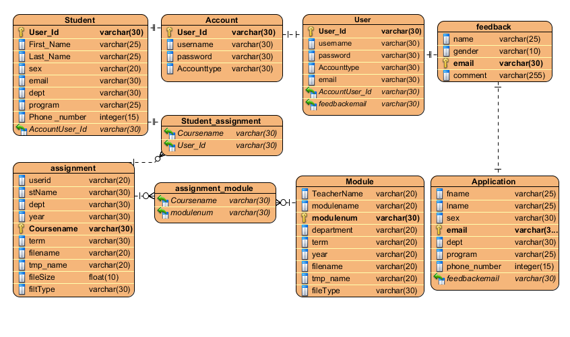

Database Design

**CHAPTER FIVE**

**Implementation deliverable of the new system**

5.1 **Introduction**

Implementation refers to the Coding of the all documents gathered starting from requirement analysis to Design phase. So now the team is in a position of converting all documents gathered and designed into the code so that the system will be implemented for the user to be used for the purpose it developed. To implement it the user must have a server on which the system will be hosted because this system can run on intranet site with connection available or on internet connection.

**5.2 Component diagram**

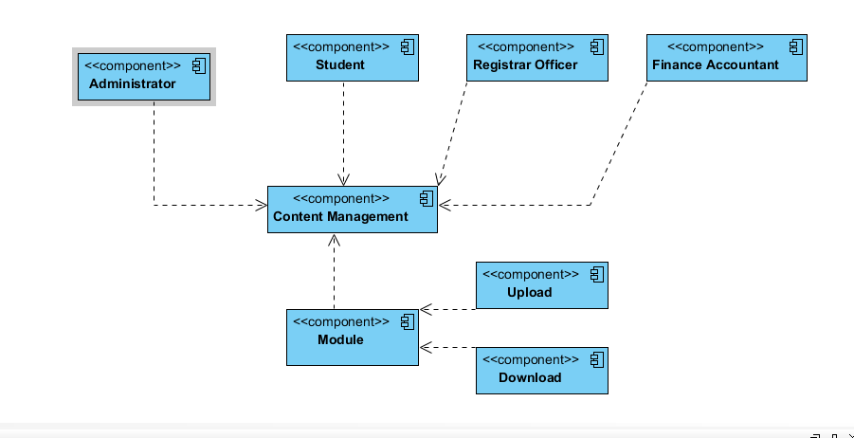In this Diagram components of the system will be wired showing that there is relation among components, management of the system, database and operations performed on databases such security issue. This in some extent shows which component or objects will be accessed by whom and what type of security infrastructures it is using. The diagram is simulated below.

**5.3 Deployment diagram**

Deployment modeling is used to show the hardware of the system, the software that is installed in the hardware and also the middleware that is used to connect the disparate machines to one and other. It also shows how the software and the hardware components work together.

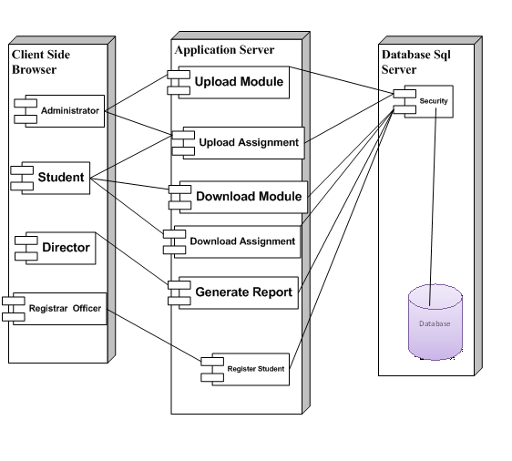

Deployment diagram

**5.4 user interface design**

In this system users will communicate with the system through the following user interfaces.

**Home Page**: This form appears on the site in which the system deployed is opened and contains some links which lead the user to other page according to his privilege, and if the user is authorized user or has an account, he/she will directly go to the page that he want by entering correct username ,password and role.



User Interface of home page

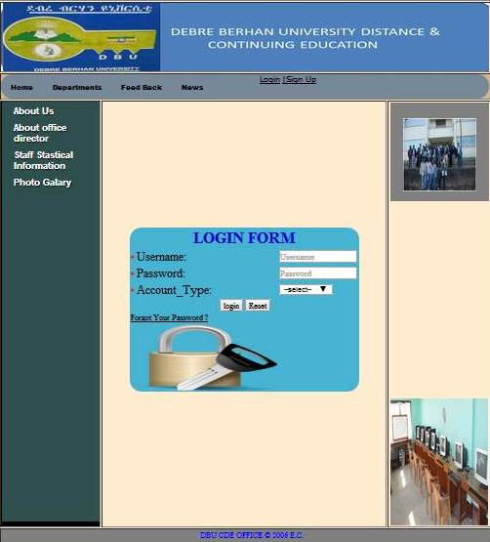

Login User Interface

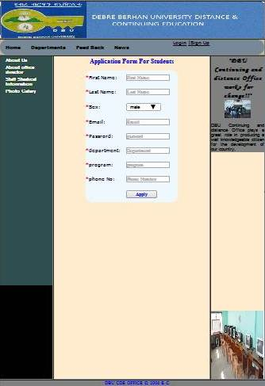

User Interface for application

**6. Prototype development**

Prototype development can be defined it is the sample code of the given project. These are some of the sample codes that we have done it.

**Sample code of application**

<?php

define("db_server","localhost");

define("db_user","root");

define("db_name","cde");

define("db_password","");

$conn=mysql_connect(db_server,db_user,db_password);

if(!$conn)

{

die("Error in connection".mysql_error());

}

$db_select=mysql_select_db(db_name,$conn);

if(!$db_select)

{

die("Error in db select".mysql_error());

}

?>

?php

if(isset($_POST['submitMain']))

{

mysql_select_db("my_db", $conn);

$sql="INSERT INTO application (First_Name, Last_Name ,Sex,Email,password,dept,program,Phone_No,status)

VALUES

('$_POST[firstname]','$_POST[lastname]','$_POST[sex]','$_POST[email]','$_POST[pass]','$_POST[department]','$_POST[program]','$_POST[phone]','$_POST[status]')";

if (!mysql_query($sql,$conn))

{

echo'<font color=red>your detail is not correct</font>';

}

else

{

echo"<imgsrc='correct.jpg' width='40' height='30'>Successfully applied !!";

}}

mysql_close($conn)

?>

Php sample code of Login

<?php

if(isset($_POST['submitMain']))

{

$acc=$_POST['select'];

$user =$_POST['mail'];

$_SESSION['mail']=$_POST['mail'];

$password=$_POST['pass'];

$_SESSION['pass']=$_POST['pass'];

$query = "SELECT * FROM account WHERE username= '{$user}' AND password= '{$password}' AND accounttype='{$acc}';";

$result_set=mysql_query($query);

if(!$result_set){

die("query is failed".mysql_error());

}

if(mysql_num_rows($result_set)>0)

{

if($acc=='admin')

{

$_SESSION['validuser']=$user;

echo "<script>window.location='admin.php';</script>";

}

else if($acc=='finance')

{

$_SESSION['validuser']=$user;

echo "<script>window.location='finance.php';</script>";

}

else if($acc=='student')

{

$_SESSION['validuser']=$user;

echo "<script>window.location='student.php';</script>";

}

else if($acc=='registrar')

{

$_SESSION['validuser']=$user;

echo "<script>window.location='registrar.php';</script>";

}

}

else

{

echo '<div align="center"><strong><font color="#FF0000">Invalid Input!!</font></Strong></div>';

}

mysql_close($conn);

}

?>

**CONCLUSION**

This project which has two phases; the first phase concerned with the analysis phase of the life cycle, the design phase and the next phase is about implementation. As the end of the first phase, we need to review that we have covered in accordance with what we have planned at the beginning. We began our work by identifying the significance of automated system for the store and the overall techniques to be used in the development process. This involved defining the system development methodology, identifying process. This involved defining the system development methodology, identifying resource and cost requirements, and setting the deliverable and scheduled for the project.

The analysis helps the team to well understand the major functional areas and processes of the system. Throughthis methodwe evaluate the existing system weakness and strength.

After that, we performed requirements elicitation to discover user and system requirements. This phase consisted of drawing the functional as well as non-functional requirements of the system. Then we have undertaken a major phase in system development process: object oriented Analysis. Here, we tried to model the new system we proposed using UML diagrams: Use case, sequence, and activity and class diagrams Also, we designed the new system user interface prototype.

**RECOMMENDATION**

The system that we have tried to automate is not the whole system of the distance and continuing education. Because of time limitation and budget we can’t develop all parts of the system, but we tried to automate some sub systems and functionalities.

The following functionalities can’t be automated because of the limitations that we have discussed above.

* **Providing tutorial online**
* Online examination
* **Online video learning**
* **Online payment**
* **Online grade recieption**

**Therefore, others are interested individuals to develop on distance and continuing education can get some initial idea about the system and no need of more data gathering process the only need will be improving the system.**

**REFERENCE**

1. Brueghel, Bernd (2000) ***Object oriented Software Engineering Conquering Complex and Changing System.*** Upper Saddle River: Prentic Hall.
2. **Books available in the library**
3. The ***Object primer: The application Developers Guide to Object Oriented and the UML***.2nd rev. Ed England: The Colombia University.